**BAW INSTALLATION 19.0.0.1 ON LINUX**

**Introduction:**

IBM Business Automation Workflow is a platform to create workflow applications to improve productivity.

**1. Installation Overview:**

***High Level Overview of BAW Installation***

* Install Oracle12c release 2.
* Install Installation Manager v1.8
* Install Websphere Application Server 8.5.5.0 and apply fixpack to update to version 8.5.5.15
* Install BAW 8.6.1.18001
* Apply Cumulative Fix 19001

2. PREREQUISISTES

* Oracle Database 12c Enterprise Edition Release 2 instance is available on database server.
* Set ORACLE_HOME to Oracle home directory.
  + export ORACLE_HOME= /u01/app/oracle/product/12.2.0.1/db_1
* add ORACLE_HOME/bin to PATH
  + export PATH=$PATH+$ORACLE_HOME/bin

Details required for installation and configuration of BAW 8.6.1.19001

Section A--Installation Manager Details

|  |  |
| --- | --- |
| Installation Manager Home | /opt/IBM/InstallationManager |
| Installation Manager Shared Resources directory | /opt/IBM/IMShared |

Section B-- WebSphere Application Server Details

|  |  |
| --- | --- |
| WebSphere Application server home | /opt/IBM/WebSphere/AppServer |

Section C-- Oracle Database Details

|  |  |
| --- | --- |
| Oracle DB host name | ahbmdm116.eidikointernal.com |
| Oracle SID | orcl |
| Oracle user name | sys as sysdba |
| Oracle user password | sarasu10 |
| Oracle database port | 1521 |
| JDBC Driver Path | /u01/app/oracle/product/12.2.0.1/db_1 |

Before you Begin:

* Make sure all the oracle 12c release 2 software is installed under oracle user.
* BAW software is installed under root.
  1. Pre-Installation of Installation Manager
     1. Binaries:

Copy all the required BAW Software binaries to a location on the server.

* Go to the path where the installation files are copied.

**/home/oracle/Documents/BPM_BAW/**

* Unzip the three files.

**BAW_18_0_0_1_Linux_x86_1_of_3.tar.gz**

**BAW_18_0_0_1_Linux_x86_3_of_3.tar.gz**

**BAW_18_0_0_1_Linux_x86_2_of_3.tar.gz**

* Extract the above files to install IM, WAS and BAW software.

**2. Installing Installation Manager:**

a. Go to Installation Manager extracted folder, run the below command.

**./install**

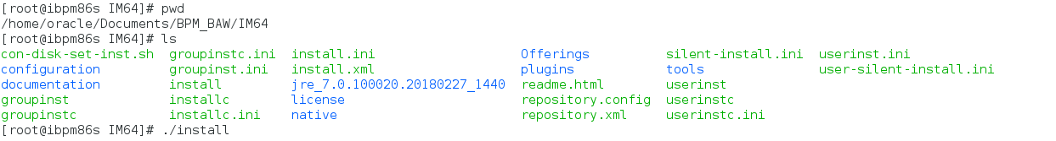

b. In the install packages screen, we can see the packages that are going to be installed. Check and click **Next**

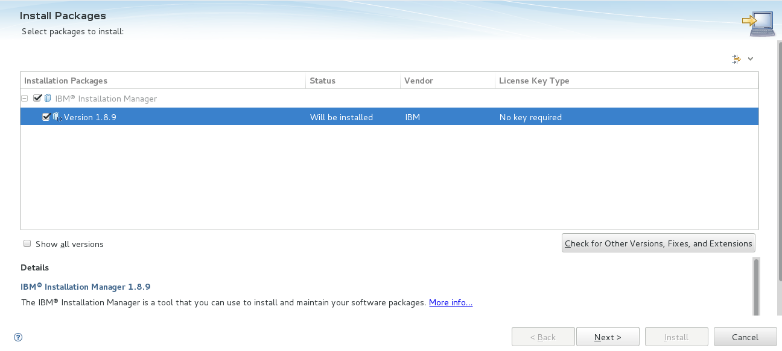

c. In the Accept the license screen, check the “Accept” button and click **Next**

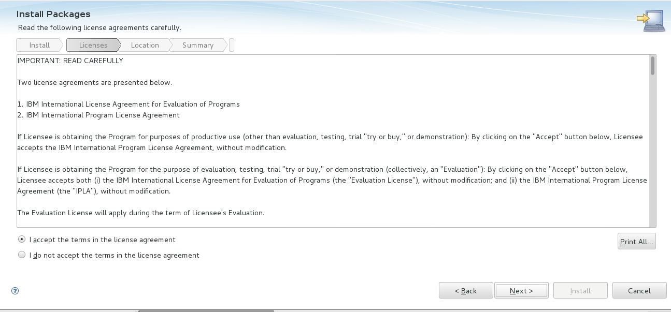

d. Give the Installation location of Installation Manager and click **Next**

Installation Directory: **/opt/IBM/InstallationManager/eclipse**

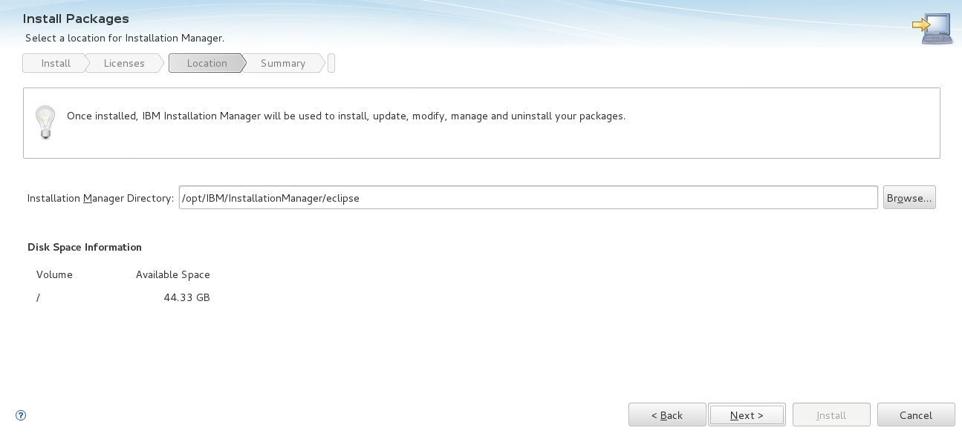

e. Click **Install**, to install Installation Manager

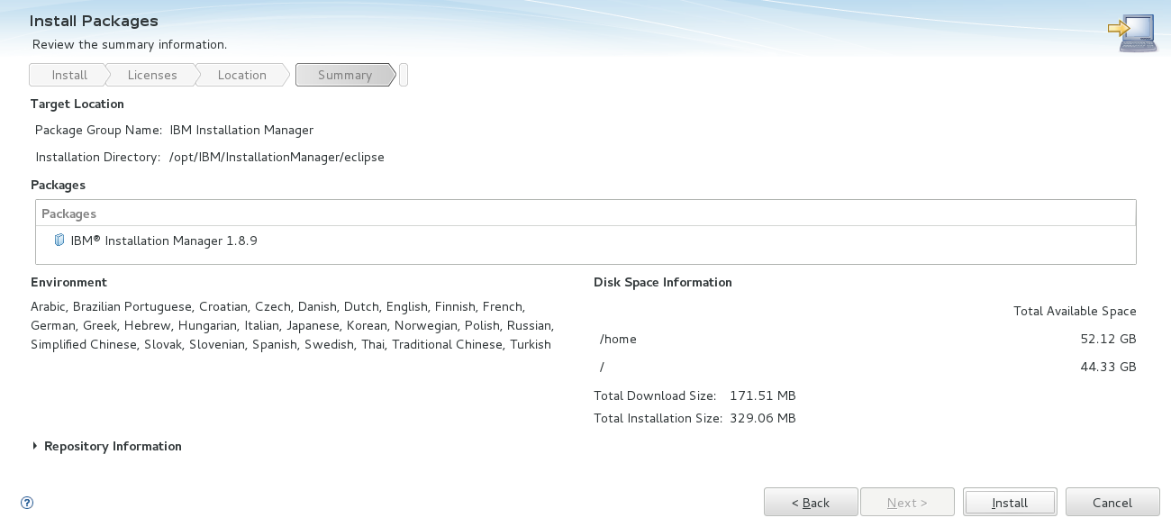

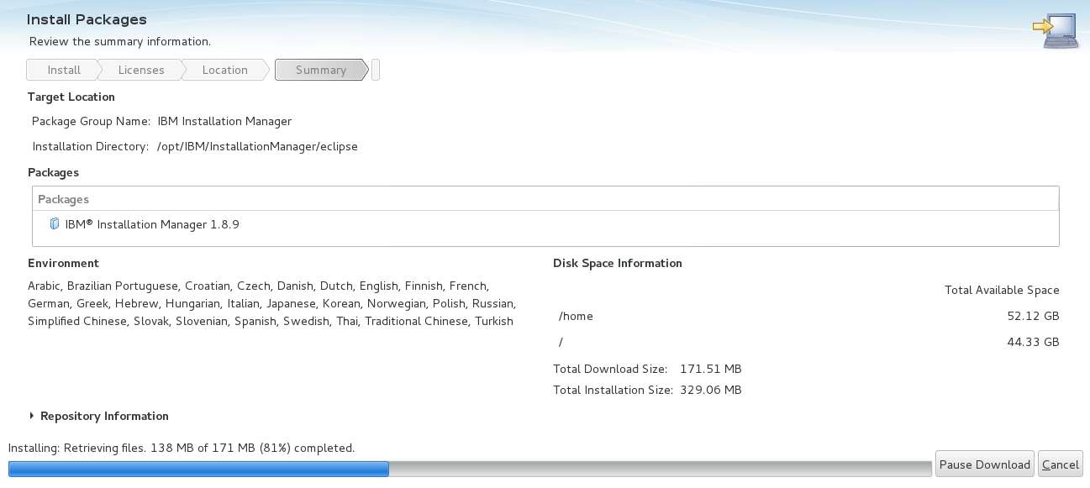

f. We can verify that installation successfully completed .

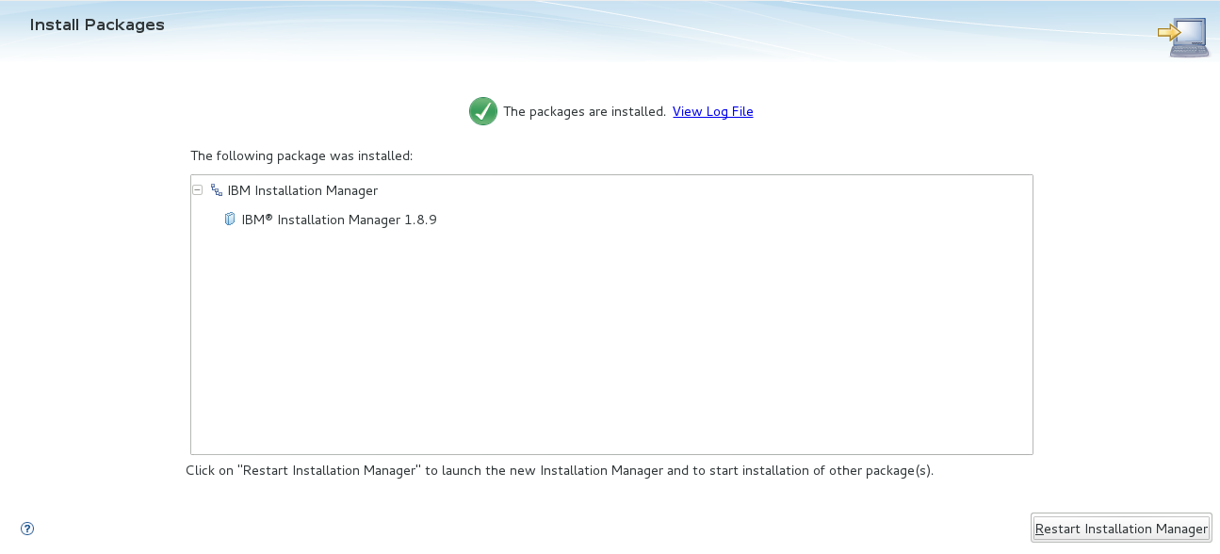

**NOTE**:

Before Installation of BAW set the kernel parameter values in limits.conf file.

Go to **/etc/security/limits.conf** file.

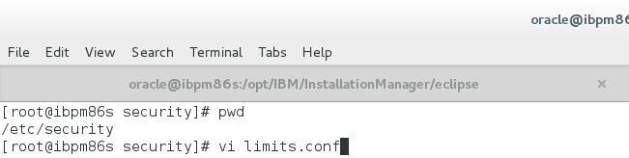

Set the kernel parameter shown below and save the file.

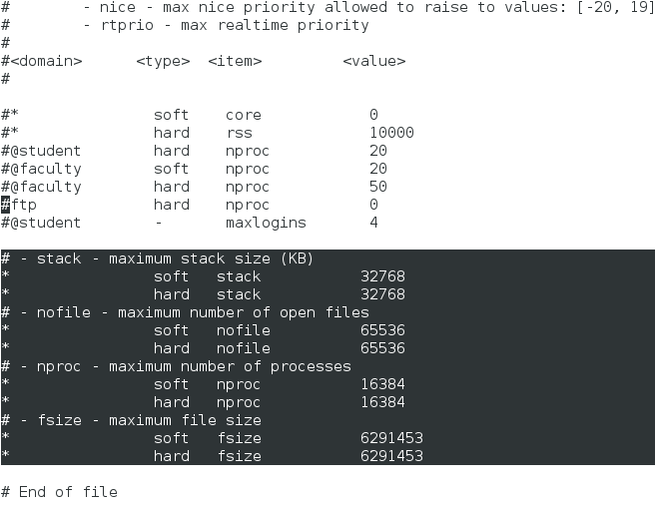

To effect the above high lighted values, just **logout** the user account and **login** to the same user.

Run the command **ulimit -a**

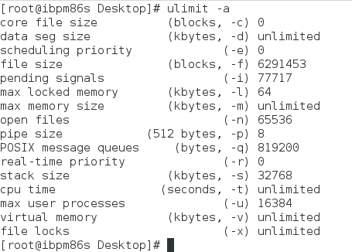

3. **INSTALLATION OF IBM WEBSPHERE APPLICATION SERVER & BAW:**

* Go to the path

**/opt/IBM/InstallationManager/eclipse**

* Run the following command

**./IBMIM**

* The GUI of installation manager opens.

**Go to File-->Preferences**

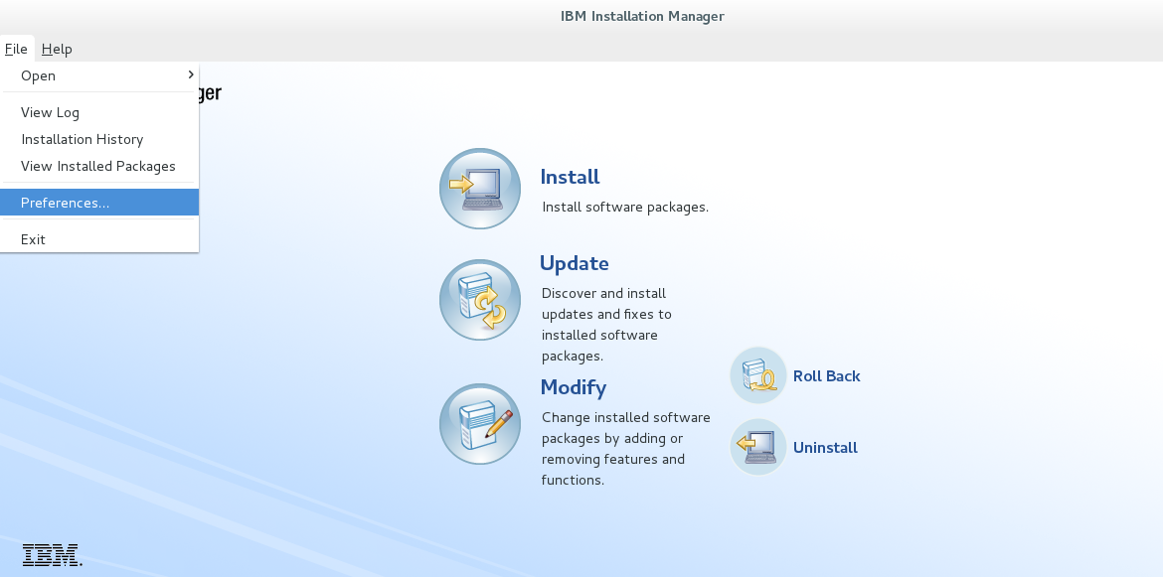

* Click on Add Repository, Click on Browse, Select the repository.config file from the extracted folder of BAW. Click OK and again OK.

**/home/oracle/Documents/BPM_BAW/repository/repos_64/repository.config**

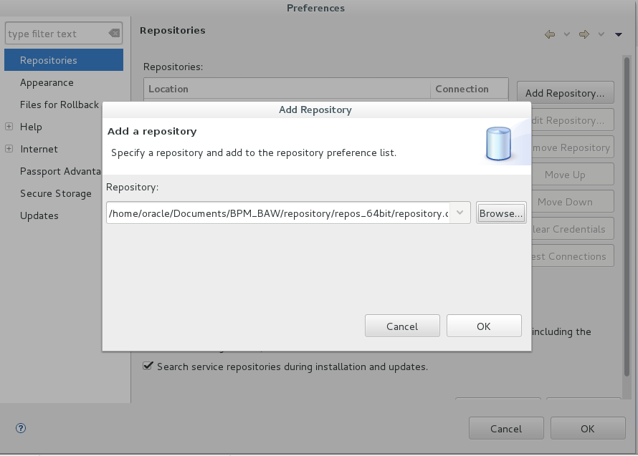

Click on Test Connections, click on ok.

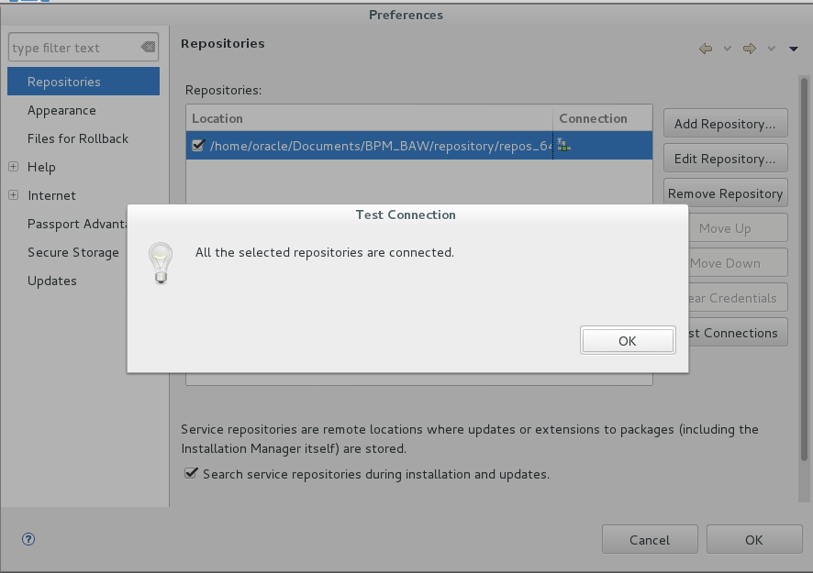

* Click on Apply and Click on OK.

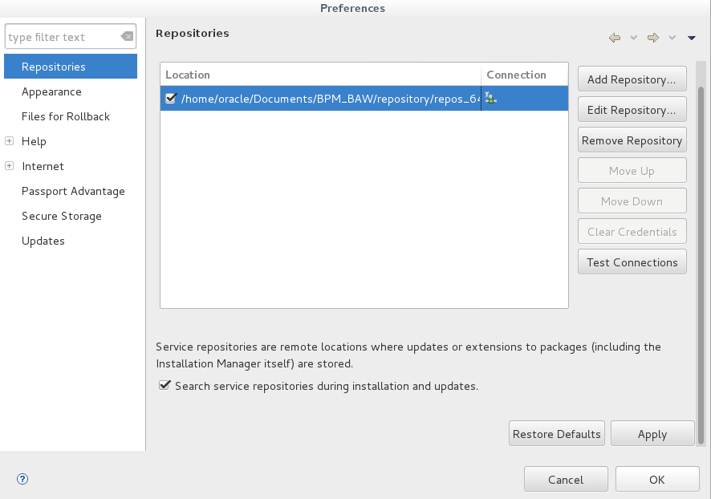

* Click on Install, to install WAS & BAW**.**

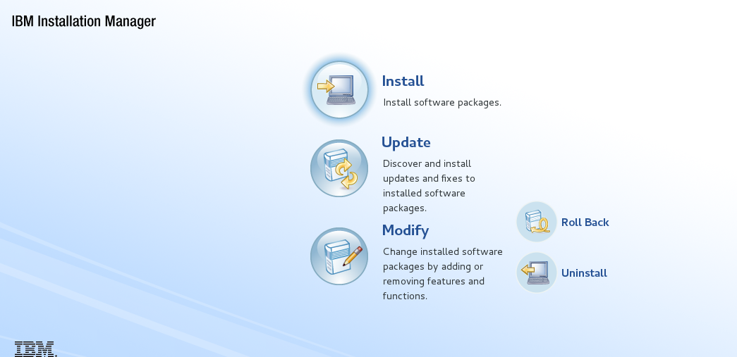

Select the packages to install.

* Click Next.

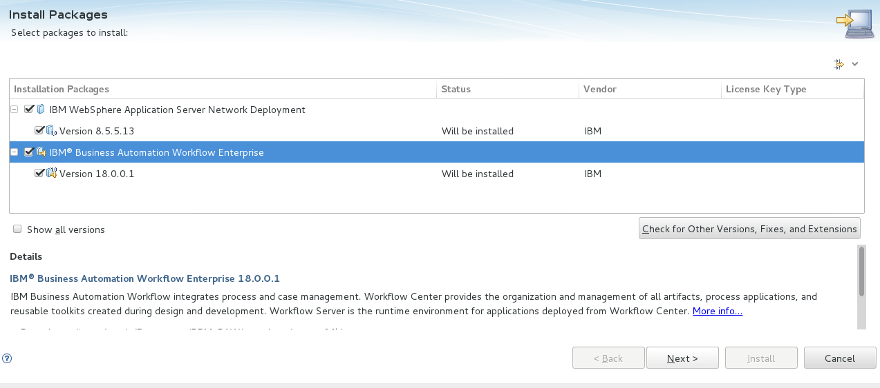

* Click on Next.

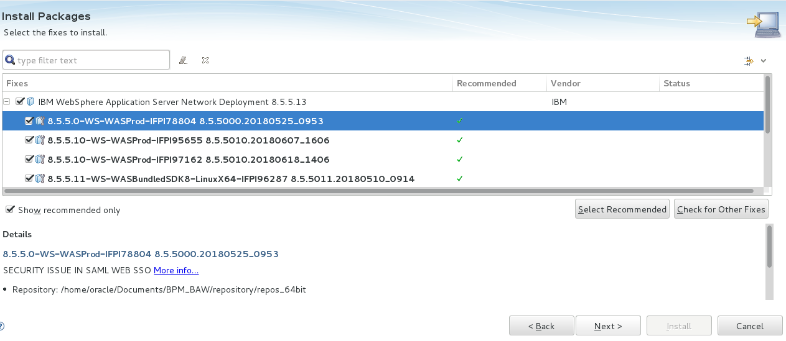

* Click on Next.

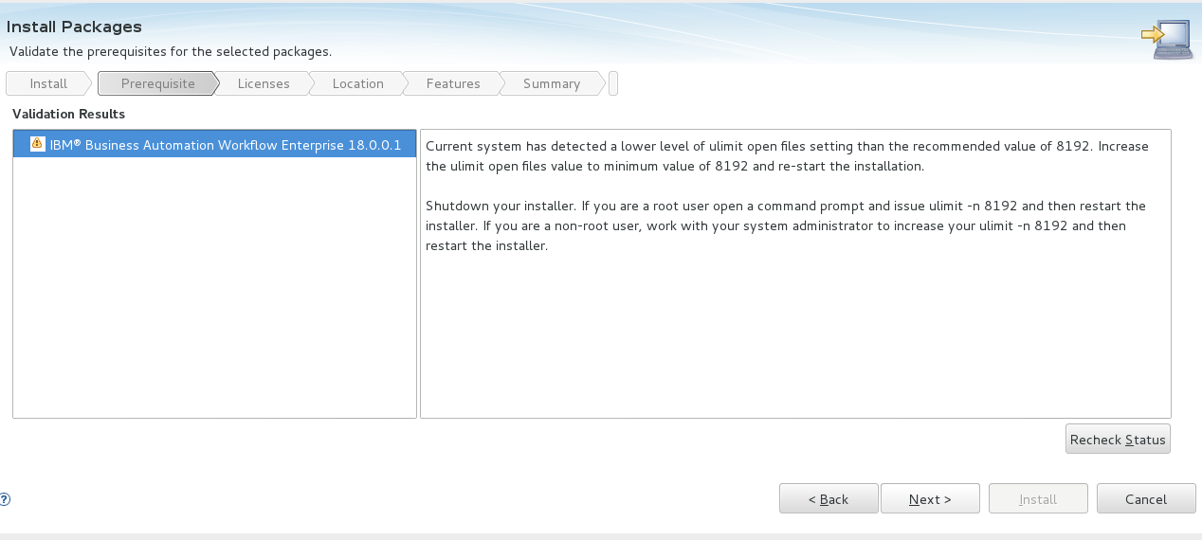

* Select the Accept and licent Agreement and click Next.

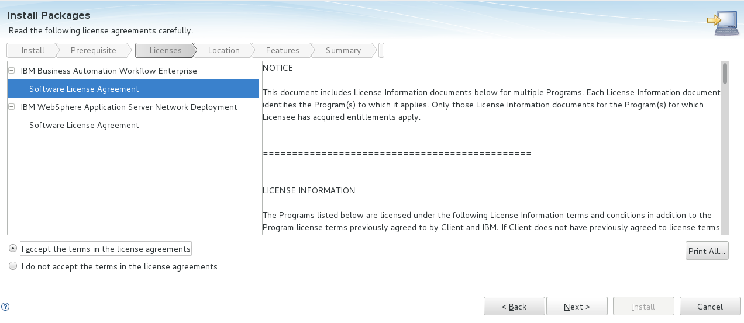

* Select the location of Shared Resourse dir.
* Click Next.

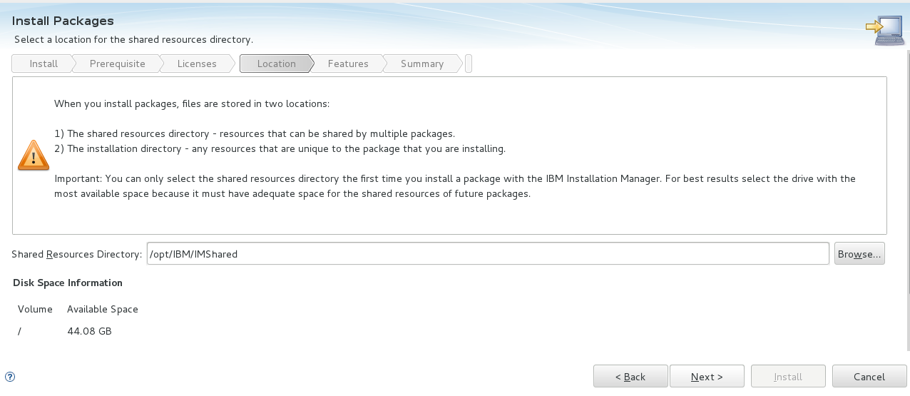

* Select the Installation directory for websphere application server. Click Next.

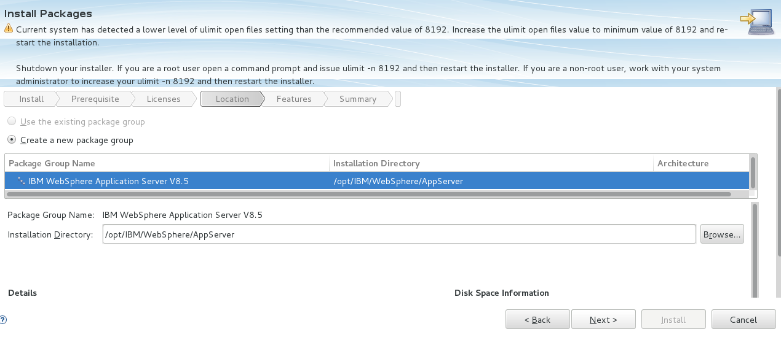

* Select the Language and Click Next.

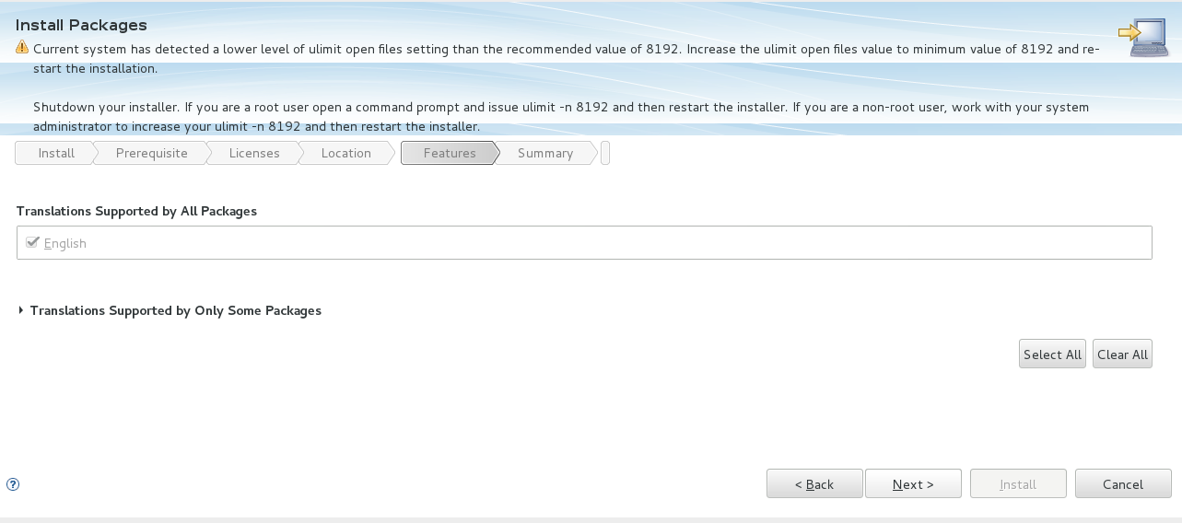

* Click Next.

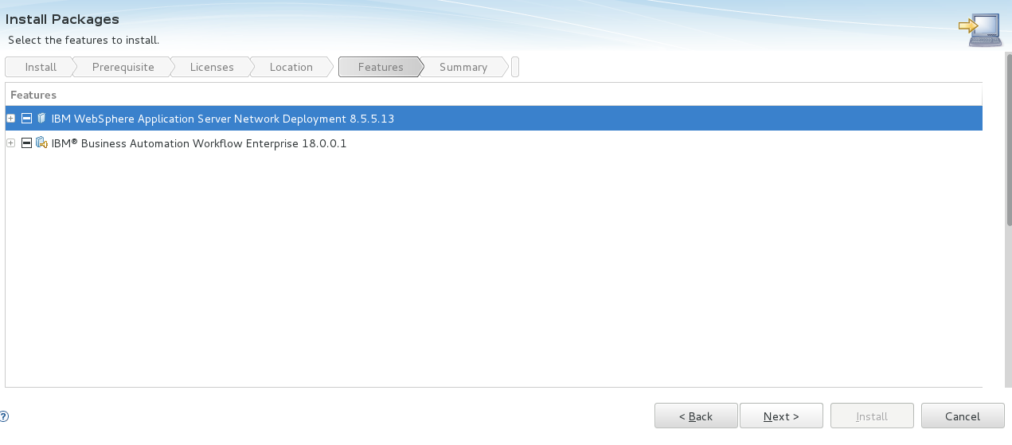

* Click Next.

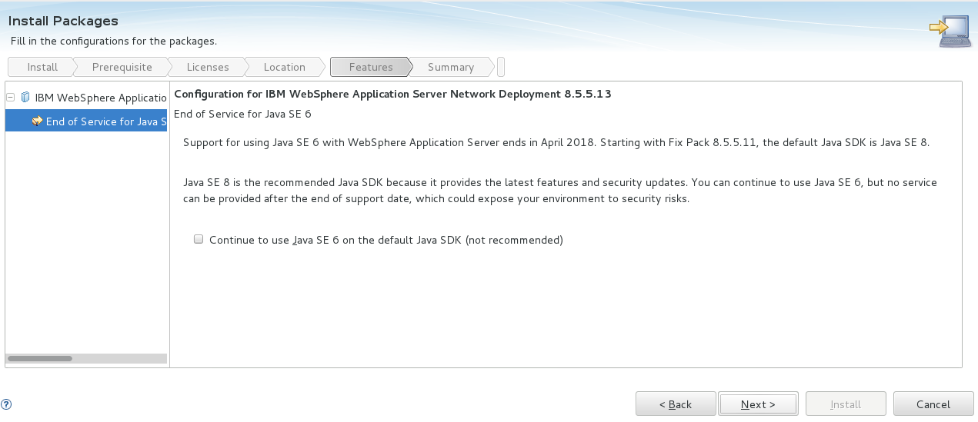

* Review the installation Summary and click Install.

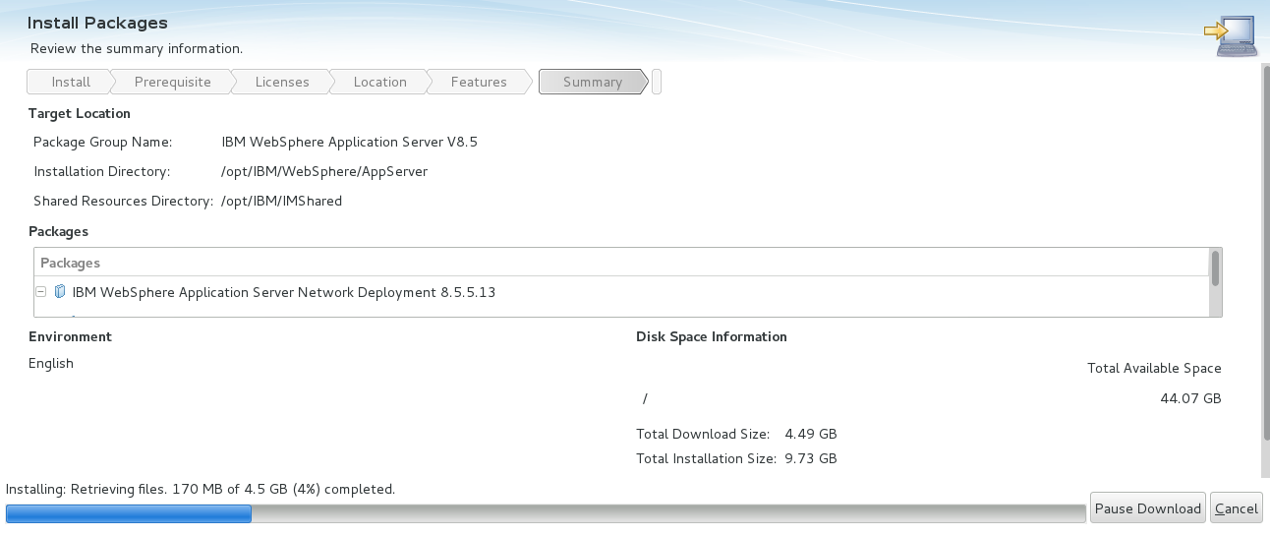

* Select None, Click Finish.

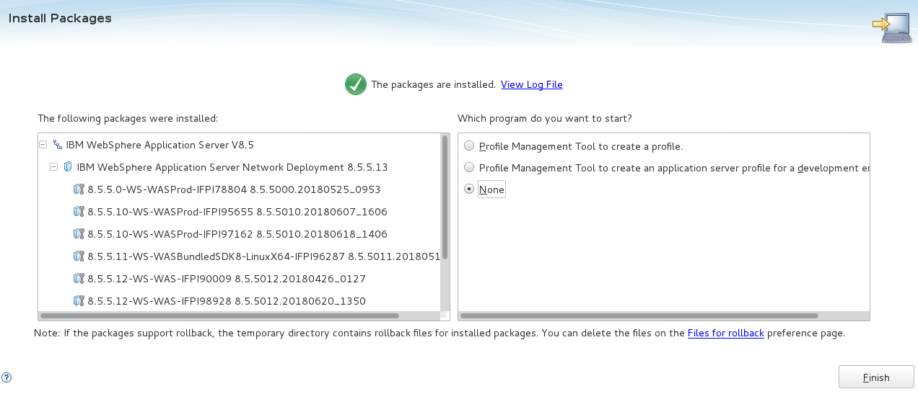

**4. Upgrading Cumulative Fix 19001 For BAW.**

* Before applying the 19001 fix, we have update the IBM WAS 8.5.5.13 to 8.5.5.15 by applying was 15 fixpack.

**4.1** **UPGARADING IBM WEBSPHERE APPLICATION SERVER FIXPACK.**

* Installing IBM Websphere Application Server and Network Deployment 8.5.5.15
* Go to the path where the installation files are copied.

/home/oracle/Documents/WAS_FP_15/

* unzip the three files

**8.5.5-WS-WAS-FP015-part1.zip**

**8.5.5-WS-WAS-FP015-part2.zip**

**8.5.5-WS-WAS-FP015-part3.zip**

* Go to the path

/opt/IBM/InstallationManager/eclipse

* Run the following command

./IBMIM

* The GUI of installation manager opens.
* Go to **File-->Preferences**



* Click on Add Repository.

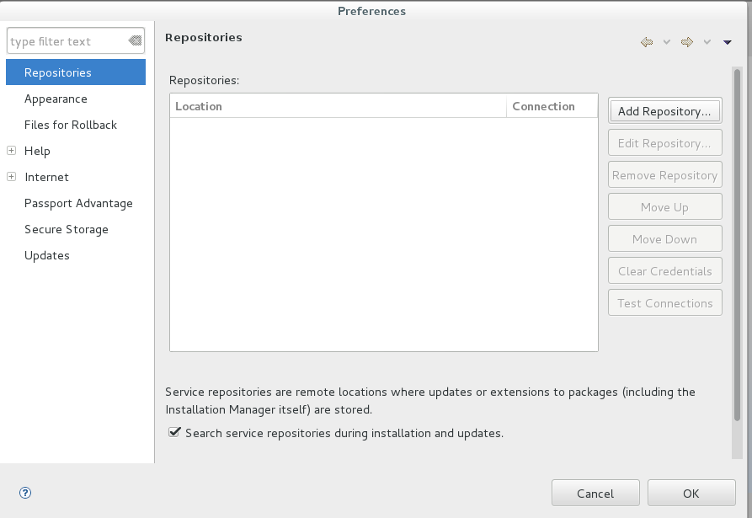

* Click on Browse.

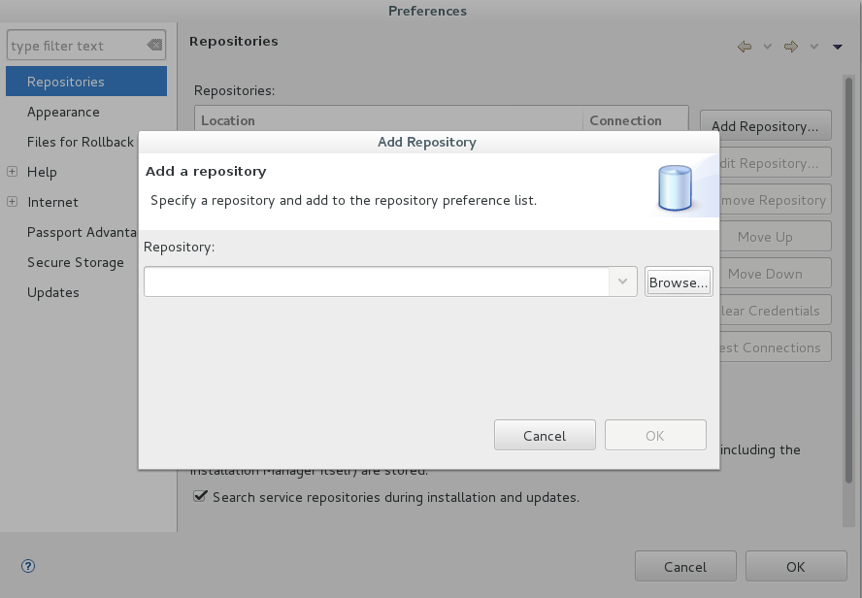

* Select the **repository.config** file from the extracted folder of WAS. Click **OK** and again **OK**.

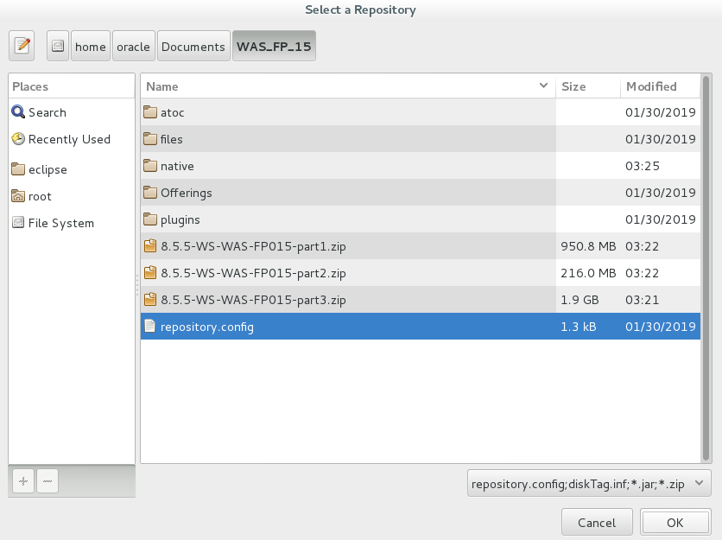

* Specify the repository and add the repository and click ok.

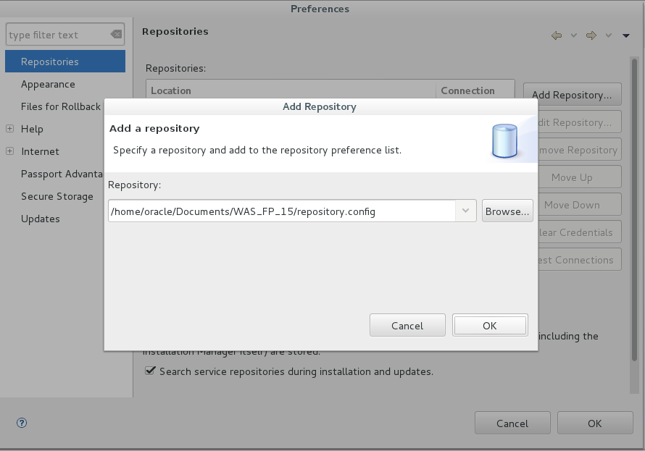

* Click on Test Connections

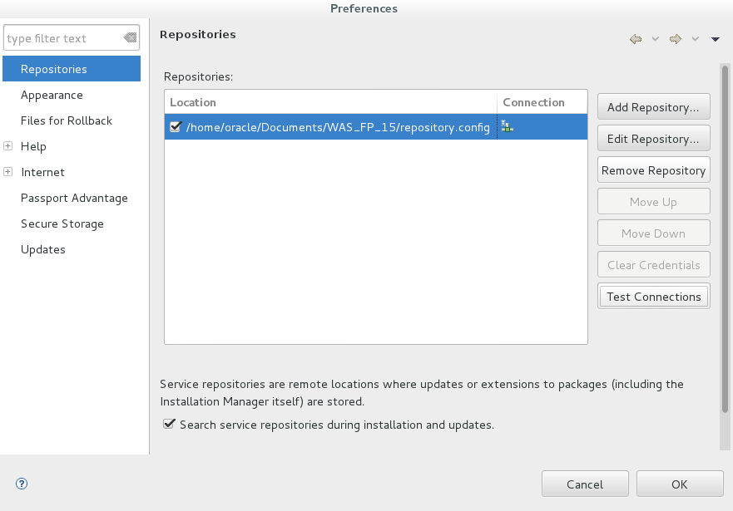

* Click on ok.

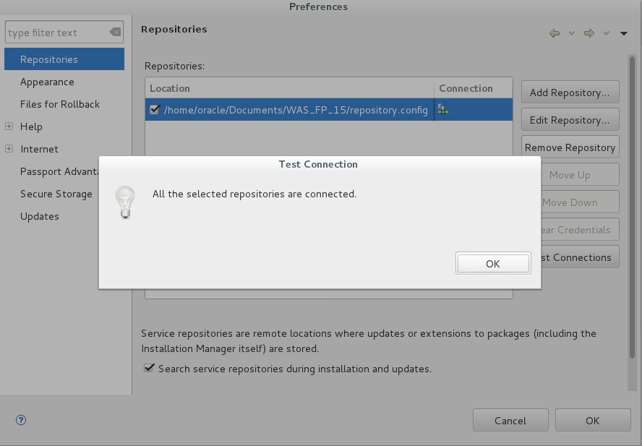

* Click Apply -> ok.

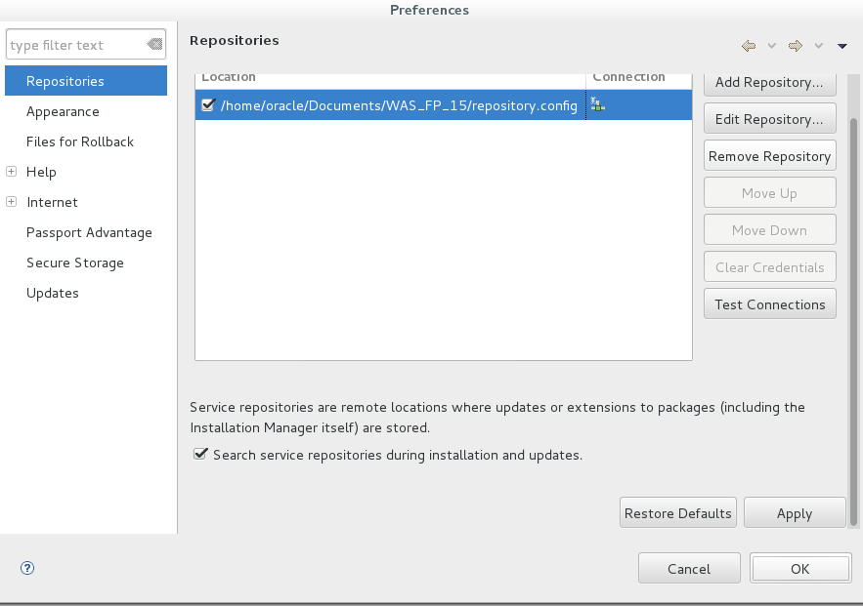

* Click on Update.

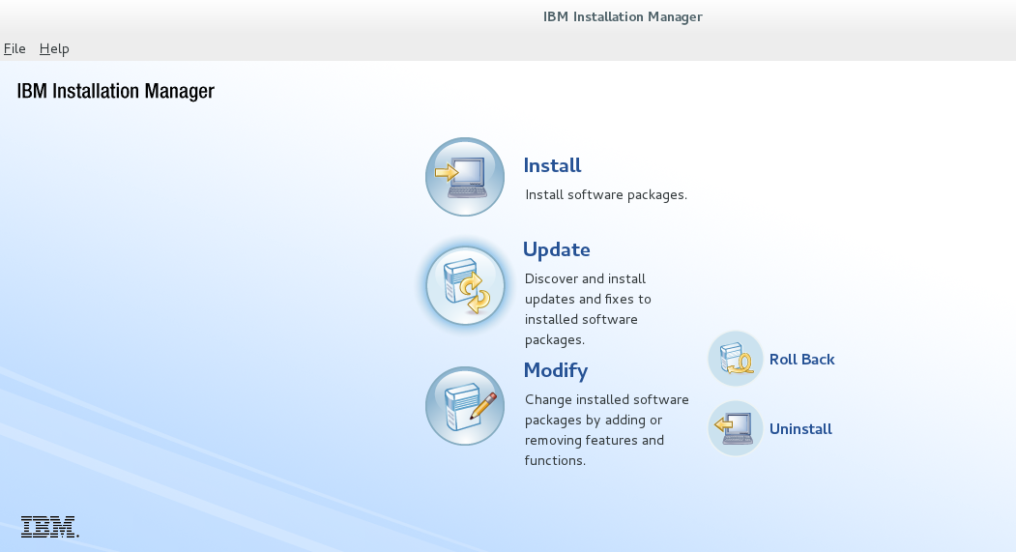

* Click on Next.

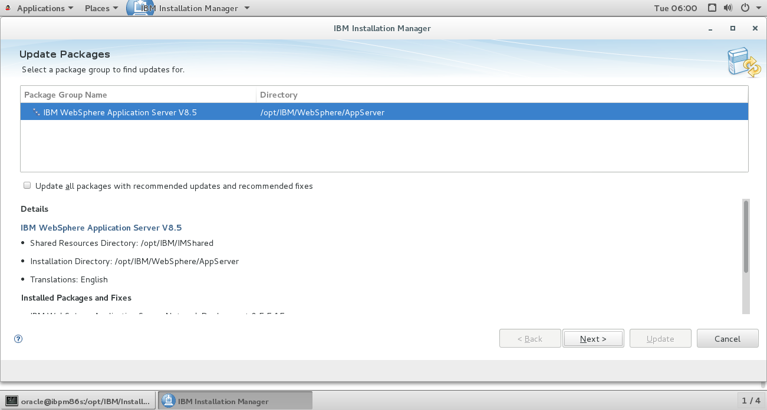

* Select I accept the terms in the License Agreement. Click on Next.

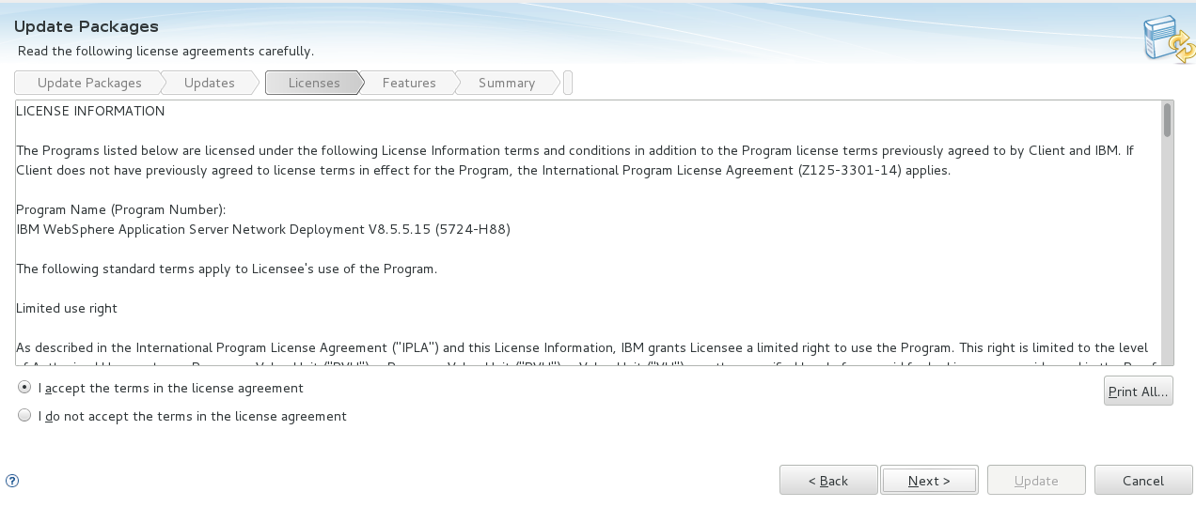Click on Next.

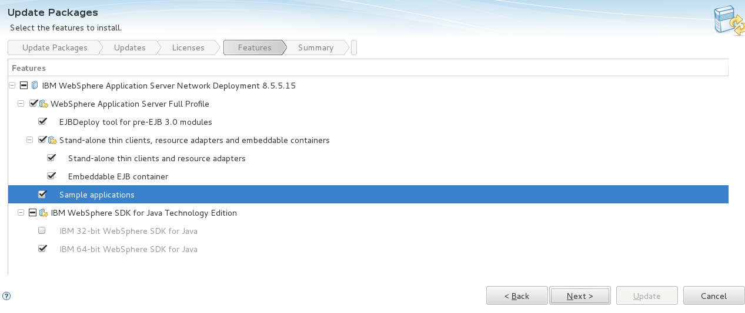

* Review the summary. Click update.

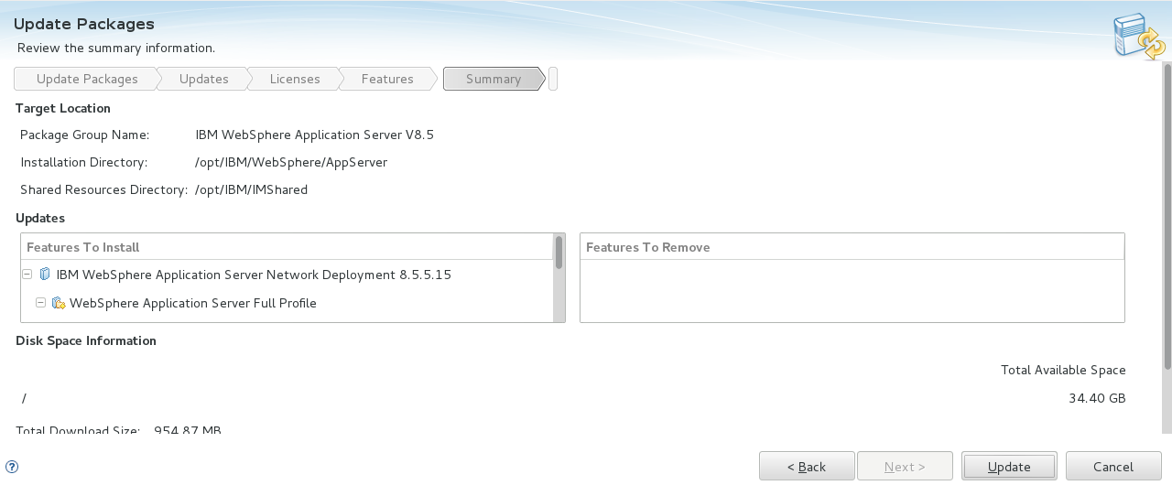

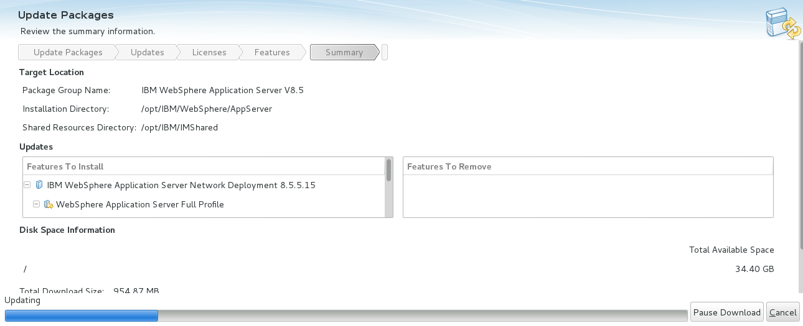

* Click on Finish.

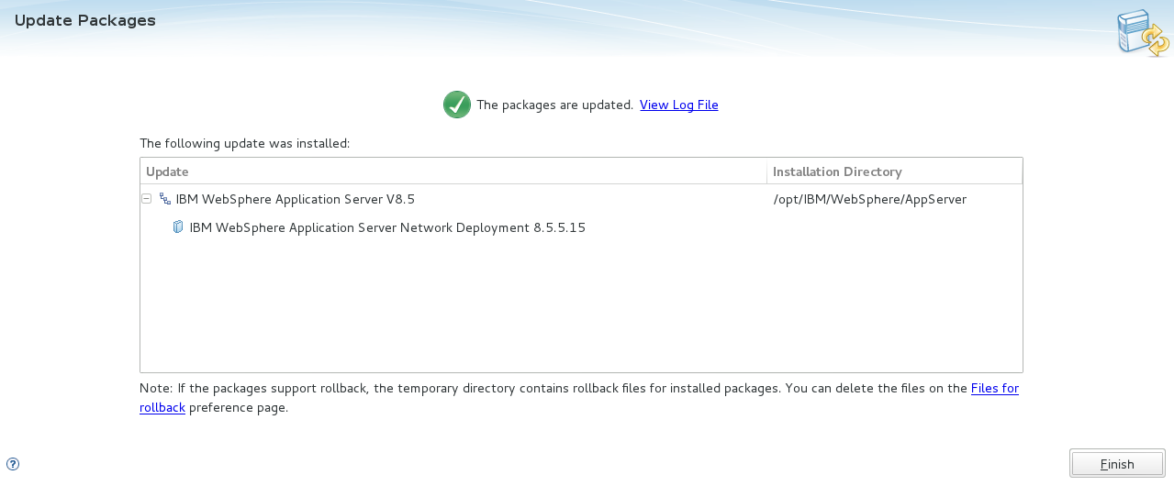

4.2 Applying 190001 Cumulative Fix.

* Go to the path where the Cumulative Fix files are copied.

/home/oracle/Documents/BAW_CF/

* unzip the file

**workflow.19001.delta.repository.zip**

* Go to the path

/opt/IBM/InstallationManager/eclipse

* Run the following command

./IBMIM

* The GUI of installation manager opens.
* Go to **File-->Preferences**



* Click on Add Repository.



* Click on Browse.



* Select the **repository.config** file from the extracted folder of WAS. Click **OK** and again **OK**.

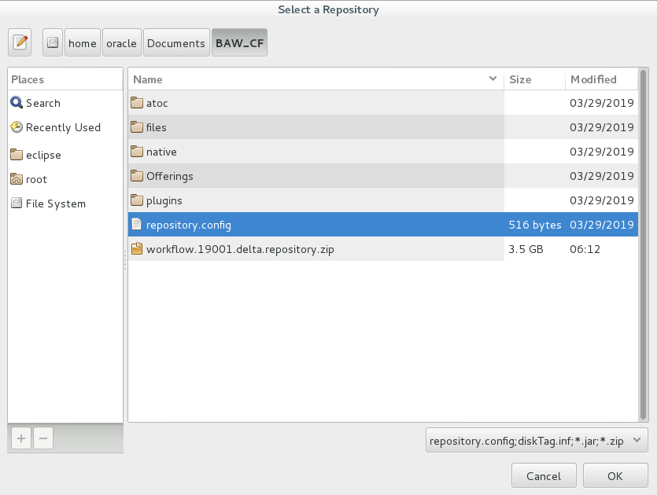

* Click on **Test Connections--> OK**

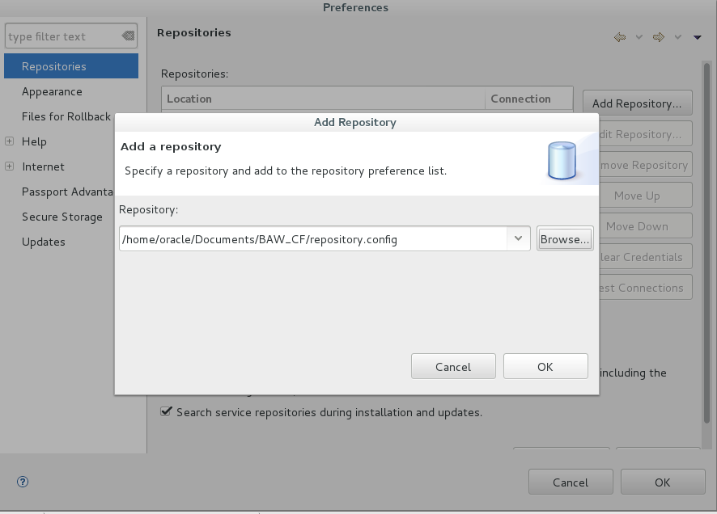

* Click on Apply and OK.

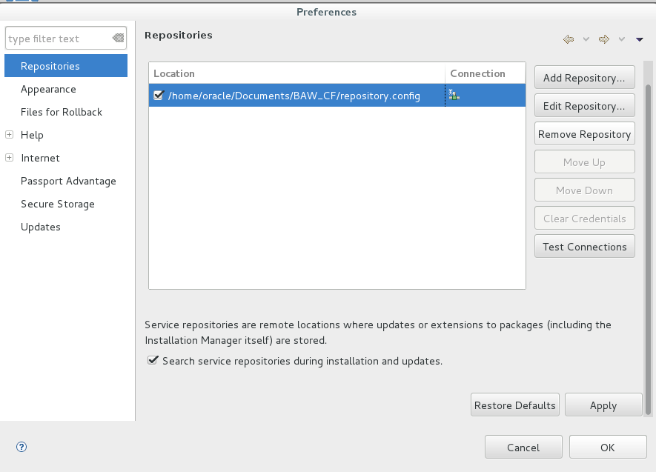

* Click on **update**

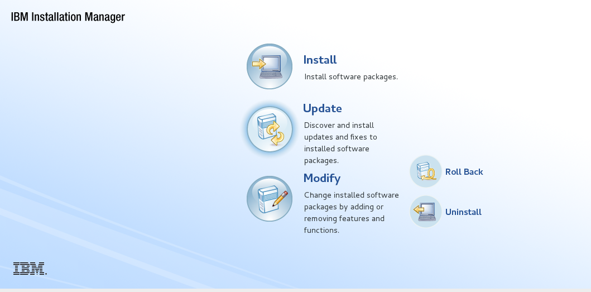

* Click on Next.

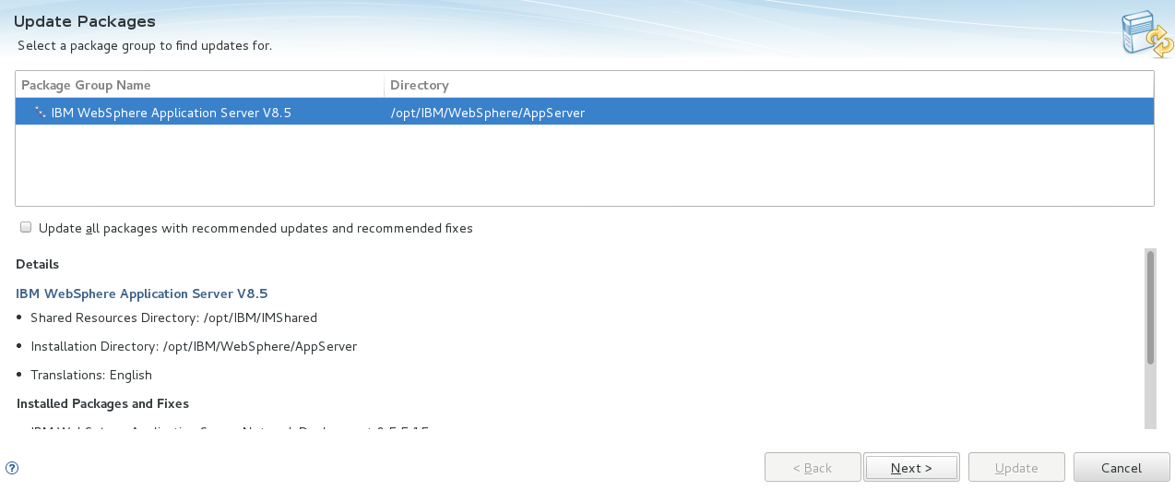

* Click on Next.
* 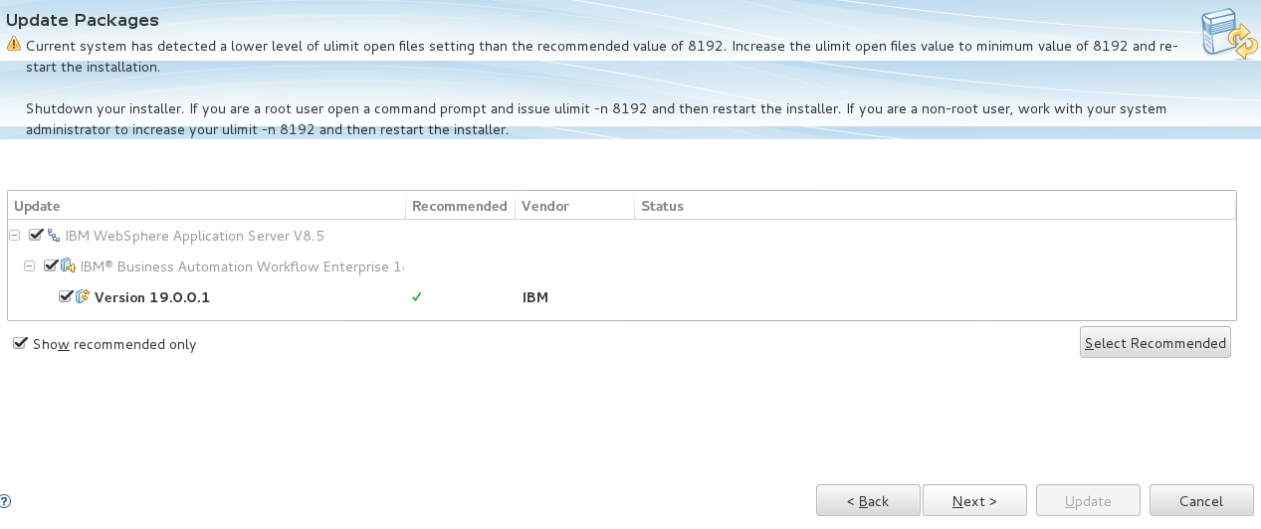Click on Next

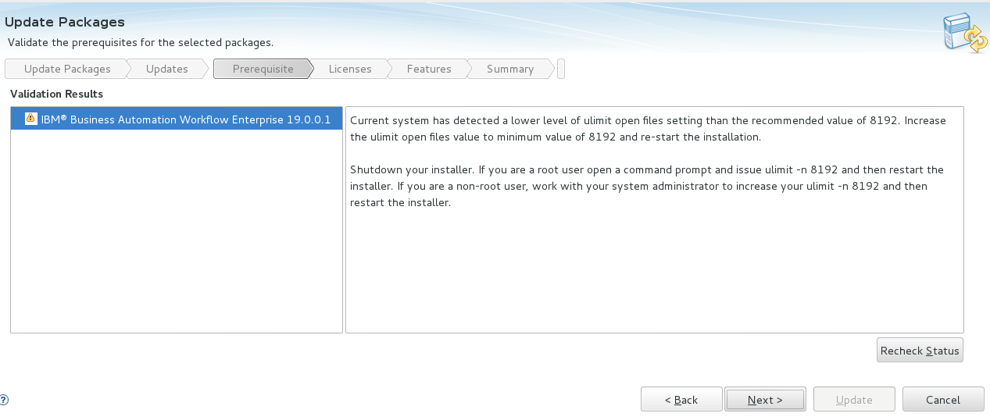

* Select the I accept the terms in the license agreement. Click **Next**.

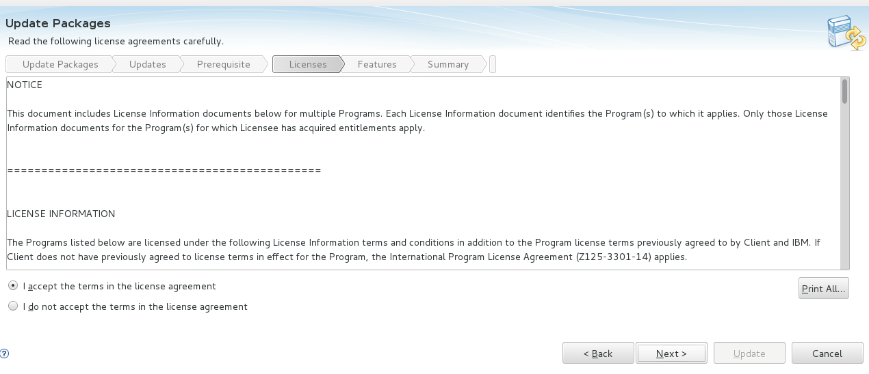

* Click Next.

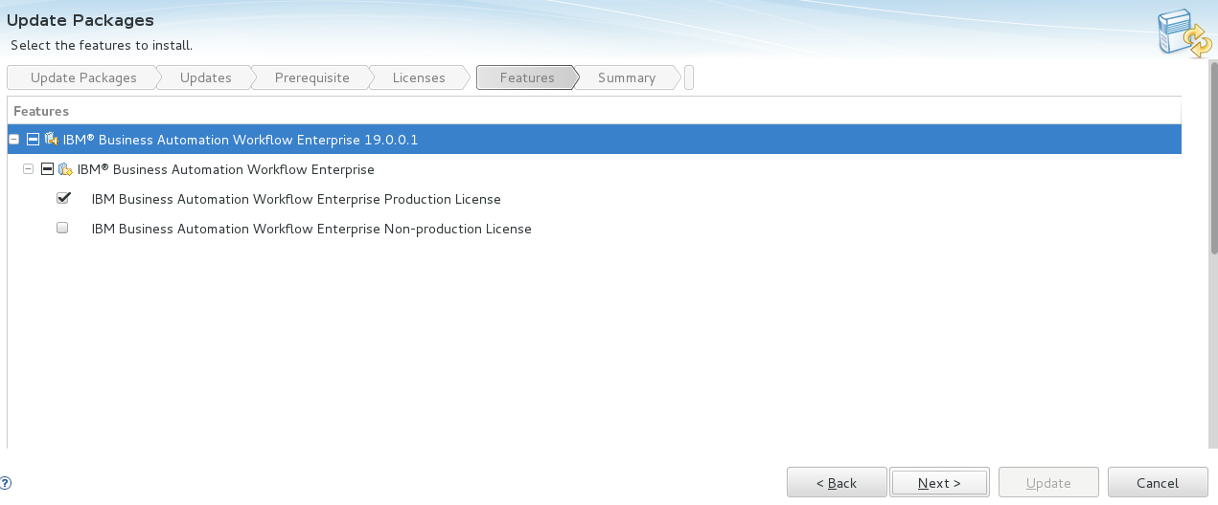

Review the installation Dir. & Click on update.

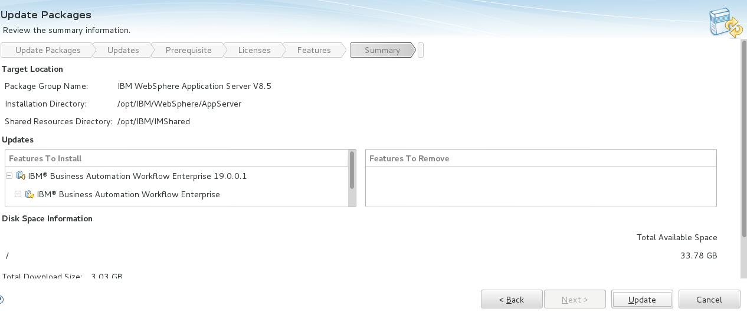

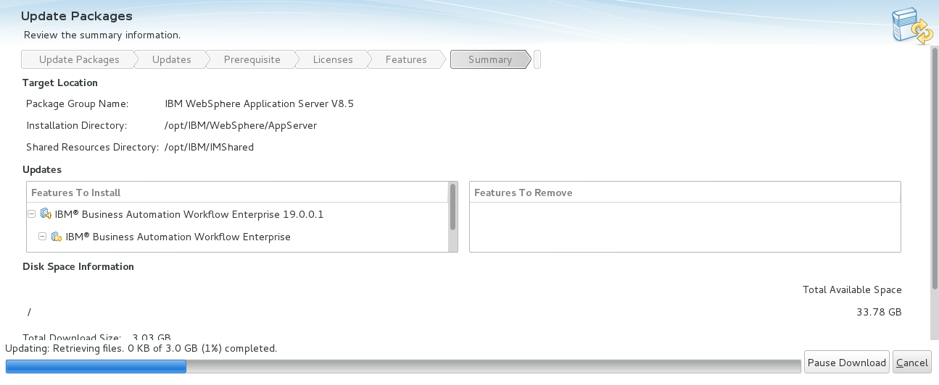

* Click on Finish.

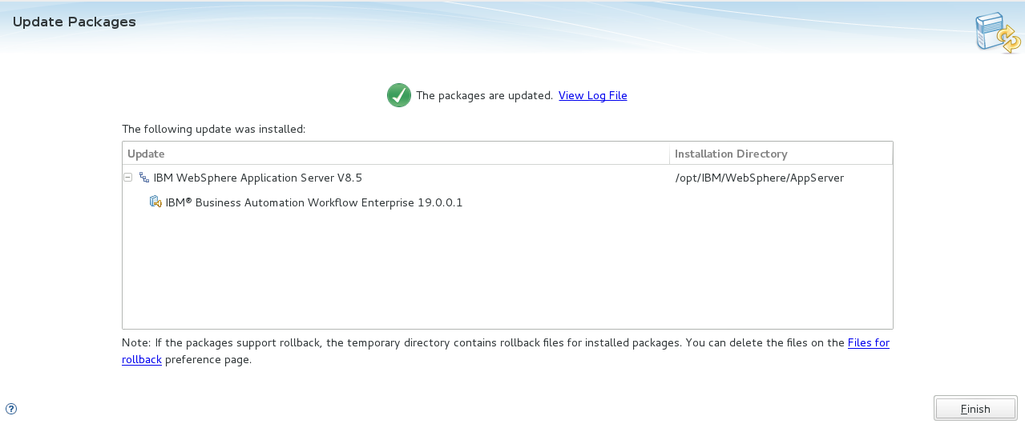

Installation of BAW successfully completed.

**5. Creating the Process Center Environment.**

* Start the listener control and oracle shown below from the oracle user.

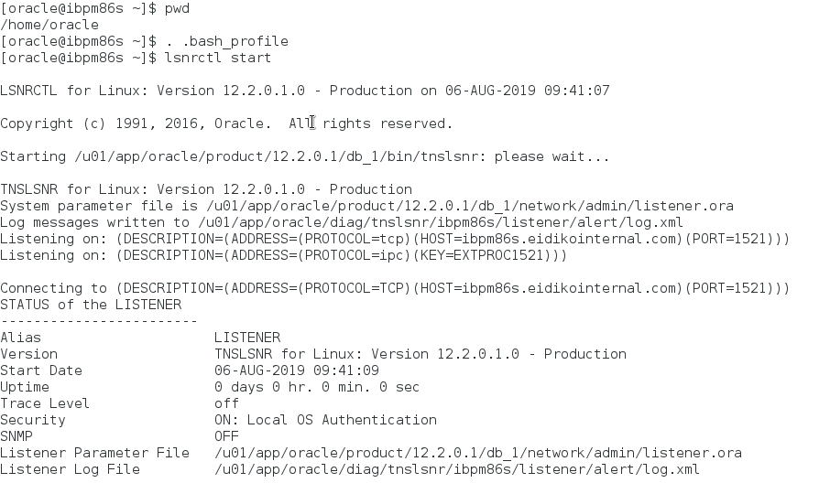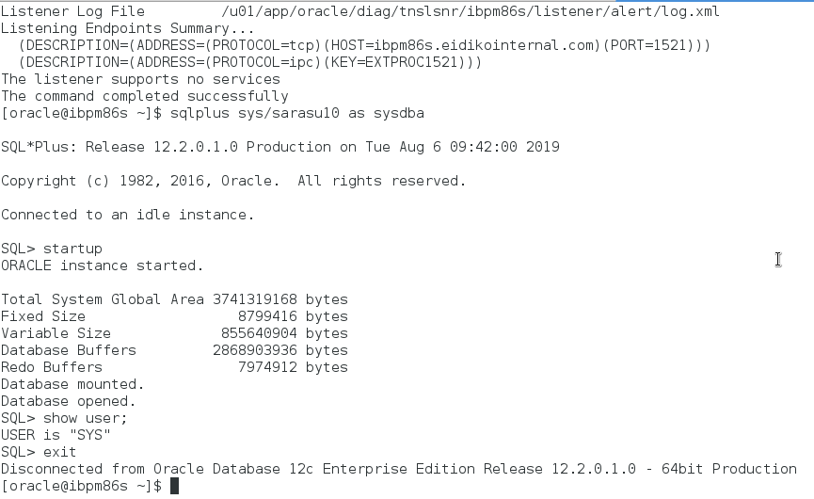

* After starting the listener control and oracle, Go to the **/opt/IBM/WebSphere/AppServer/BPM/dbscripts/Oracle/Create/** dir.
* Open the file by using vi and give the user and password values.

vi **createUser.sql**

* Run the **createUser.sql** script file from the sql to create the users.

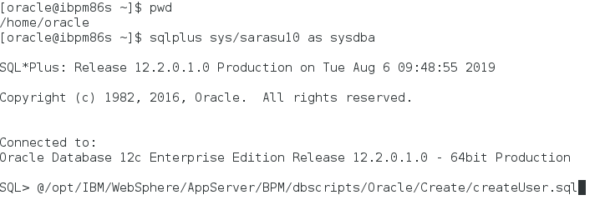

* The above script create the below users shown below.

1. bpmuser

2. cmnuser

3. pdwuser

4. dosuser

5. tosuser

6. icnuser

* Go to

**/opt/IBM/WebSphere/AppServer/BPM/samples/config/advanced**

* open the file **Advanced-PC-ThreeClusters-Oracle.properties**

vi **Advanced-PC-ThreeClusters-Oracle.properties**

* Specify the required values, and run the properties file by **BPMConfig.sh** command.
* Go to **/opt/IBM/WebSphere/AppServer/bin**

**./BPMConfig.sh -create -de /opt/IBM/WebSphere/AppServer/BPM/samples/config/advanced/ Advanced-PC-ThreeClusters-Oracle.properties**



* By running the above command it will create process center deployment environment.

6. To work with Process Center Deployment Environment.

* Start the Deployment Manager , Two Nodes and Servers.
* Starting the Dmgr Profile

Go to **/opt/IBM/WebSphere/AppServer/profiles/PCDmgr/bin**

Run the following command.

**./startManager.sh**

* Starting the Node1 Profile

Go to **/opt/IBM/WebSphere/AppServer/profiles/PCNode1/bin**

Run the following command.

**./startNode.sh**

* Starting the server **MEClusterMemeber1**

Go to **/opt/IBM/WebSphere/AppServer/profiles/PCNode1/bin**

Run the following command.

./startServer.sh **MEClusterMemeber1**

* Starting the server **AppClusterMemeber1**

Go to **/opt/IBM/WebSphere/AppServer/profiles/PCNode1/bin**

Run the following command.

**./startServer.sh AppClusterMemeber1**

* Starting the server **SupClusterMemeber1**

Go to **/opt/IBM/WebSphere/AppServer/profiles/PCNode1/bin**

Run the following command.

**./startServer.sh SupClusterMemeber1**

* Starting the Node2 Profile

Go to **/opt/IBM/WebSphere/AppServer/profiles/PCNode2/bin**

Run the following command.

**./startNode.sh**

* Starting the server **MEClusterMemeber2**

Go to **/opt/IBM/WebSphere/AppServer/profiles/PCNode2/bin**

Run the following command.

**./startServer.sh** **MEClusterMemeber2**

* Starting the server **AppClusterMemeber2**

Go to **/opt/IBM/WebSphere/AppServer/profiles/PCNode2/bin**

Run the following command.

**./startServer.sh AppClusterMemeber2**

* Starting the server **SupClusterMemeber2**

Go to **/opt/IBM/WebSphere/AppServer/profiles/PCNode2/bin**

Run the following command.

**./startServer.sh SupClusterMemeber2**

* Login to the Dmgr Console by url:

**http://<hostname>:9060/admin**